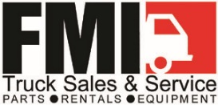

JOB DESCRIPTION: PARTS SPECIALIST

DEPARTMENT: PARTS DEPARTMENT

REPORTS TO: ASST. PARTS MANAGER

Primary Function

Sells parts to businesses and individuals from the parts sales office by performing the following duties.

Essential Duties and Responsibilities

Assist customers at the counter and on the telephone in selecting the right parts and delivery option.

Maintain parts data base and assign part numbers and descriptions.

Track open purchase orders and close purchase orders. Match receipts to purchase orders and resolve discrepancies.

Pulling Orders and Cycle counting.

Provide technical help when applicable to customers with assistance from the Service Department.

Participate in special projects or assignments as requested.

Communicate clearly in all aspects of position to all customers in person, by phone, email, FAX and written correspondence.

Qualifications

Must have intermediate computer skills, such as Microsoft Office and the ability to learn to drive a forklift.

Education and/or Experience

One year of related experience and/or training.

Physical Demands

The ability to lift up to 50 pounds, climb in and out of trucks, up and down a ladder, squat, bend and reach above your head. Also, sitting and keyboarding for long periods of time.

